INBLF - International Network of Boutique and Independent Law Firms
One Day Fly In – Vienna 2022

Date: June 3, 2022 (Friday)
Dinner: June 2, 2022 (Thursday), for those, who arrive the day before
Location of dinner: Kunz Wallentin firm – Porzellangasse 4, 1090 Vienna
Location of Fly-In: Stadtwirt Wien, Viaduktgasse 45, 1030 Vienna
Time: 10.00am-4.00pm
Attendees: If possible, more than one person per law firm, ideally one for each working group + additional guests
Costs: USD 165.00
Aim: To generate more work, especially between the European partners

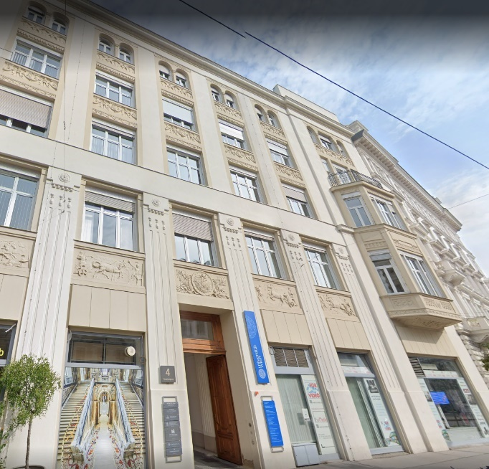
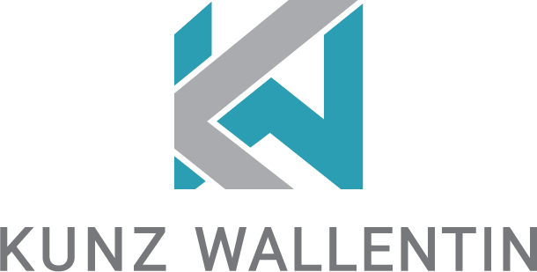

June 2, 2022
Dinner at Kunz Wallentin law firm
Porzellangasse 4, 1090 Vienna
www.kunzwallentin.at
In case of any questions, please contact
Ulrike Wittmann – ulrike.wittmann@kunz.at
+43 699 126 09 312

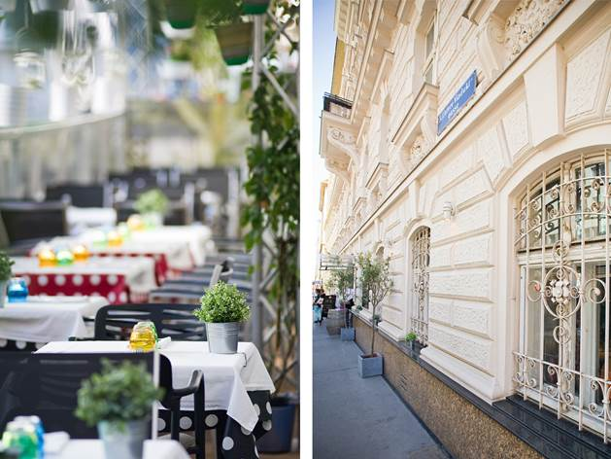

June 3, 2022
Vienna Fly-In
at Stadtwirt Wien
Viaduktgasse 45, 1030 Vienna
www.stadtwirt.at

Our team and presenters at the Vienna Fly-In

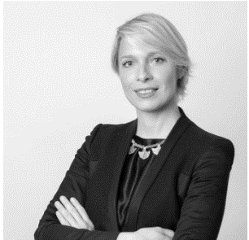
Dinka Kovačević
Partner at kp&s (Croatia)
- M&A/Corporate
- Restructuring & Insolvency
- Labour Law
- Real Estate
dinka.kovacevic@kps-law.com | www.kps-law.com

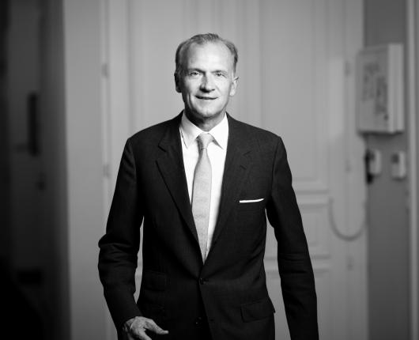
Peter Kunz
Conference Chair
Founding partner at Kunz Wallentin (Austrian INBLF member)
- M&A/Corporate
- Real Estate
- Trusts and Successions
- Italian Desk
peter.kunz@kunz.at | www.kunzwallentin.at
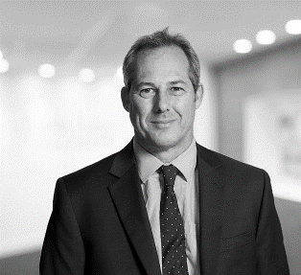
Clive Lee
President of the European Chapter INBLF
Partner at DMH Stallard (British INBLF member)
- Litigation
- Customs, Tax and Duty Disputes
- Fraud recovery
Clive.Lee@dmhstallard.com | www.dmhstallard.com

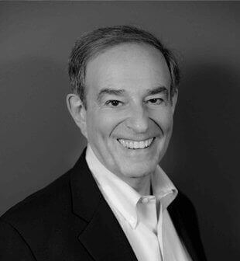
Arnie Lutzker
President of INBLF
Senior Partner at Lutzker & Lutzker (Washington INBLF member)
- Copyright Law
- Trademarks and Brand Protection
- Internet and Social Media
- Privacy, AI and Cybersecurity
arnie@lutzker.com | www.lutzker.com
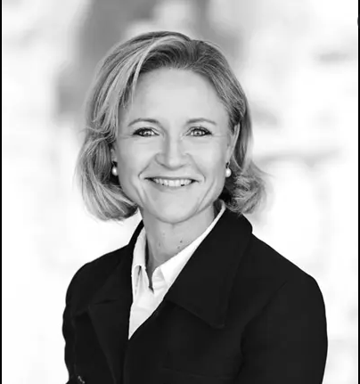
Claudia S. Mathiasen
Managing Partner at Winslow (Denmark)
- Real Estate
- Commercial rent
- Contracts

csm@winlaw.dk | www.winlaw.dk

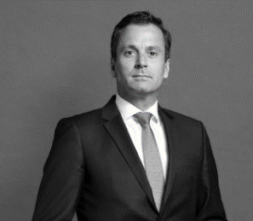
Sebastiaan Moolenaar
Vice-President of the European Chapter INBLF
Partner at AKD Benelux Lawyers (Dutch INBLF member)
- Transport & Trade
- Commercial Contracting
- (International) Litigation
smoolenaar@akd.nl | www.akd.eu

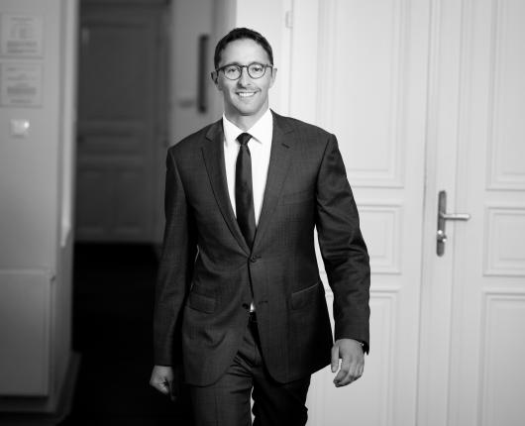
Thomas Seeber
Partner at Kunz Wallentin (Austrian INBLF member)
- New Technologies
- Real Estate
- Banking & Finance
- Italian Desk
thomas.seeber@kunz.at | www.kunzwallentin.at

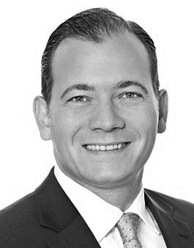
Peter Vocke
Partner at HKLW (Germany)
- Real Estate
- Property Management

p.vocke@heuking.de | www.heuking.de

Programme
Time | No | Topic
 |  | Introduction (plenary session) by Peter Kunz
10.00 am |  | Introduction of Law Firm and lawyers (approx. 40 minutes)
 |  | Name of lawyers
 |  | Full service?
 |  | Fee earners?
 |  | Inbound (Main countries) / outbound (Main countries): What kind of work?
10.40 am | Coffee break and networking (approx. 20 minutes)
 |  | Market and business opportunities (working groups)
11.00 am |  | Cross border (approx. 1.5 hours) moderated by Peter Kunz and Dinka Kovačević
11.00 am |  | M&A working group  - Market, main investors  - Restrictions for foreign investors?  - Interesting investment possibilities?  - What are possible deals?  - What return can be achieved?  - How high are the borrowing costs?  - Are asset or share deals more common?  - Are there areas where anti-trust regulations are problematic, particularly because of their existing market density?
11.00 am |  | Real Estate working group moderated by Thomas Seeber and Claudia S. Mathiasen  - Market, main investors  - Restrictions for foreign investors?  - Interesting investment possibilities in commercial or residential real estate?  - What are possible deals?  - What return can be achieved?  - How high are the borrowing costs?  - Current situation  - Observable changes to the market  - especially: COVID-19 & ESG
11.00 am |  | Litigation working group moderated by Sebastiaan Moolenaar  - quality standard of local courts (independence, length, costs etc), same chances for foreigners?  - Advantages and disadvantages of litigation / arbitration / other out of court dispute resolution  - Virtual court hearings (e.g. via ZOOM?); which court hearings and which parts of court hearings can be executed this way?  - witness questioning?  - party questioning?  - criminal / civil law?
12.30 pm | Lunch break and networking (approx. 1 hour)
 |  | Legal approach in different countries (plenary session)
2.00 –  3.00 pm |  | Data storage and cyber security: Cloud vs own server  (approx. 20 minutes) presentation by Sebastian Böhm (technical expert) and Arnie Lutzker
 |  | Differences in various countries
 |  | Employees and office spaces: Open space vs traditional law office vs home office (approx. 20 minutes) moderated by Peter Vocke
 |  | Current situation and how to acquire (and hold onto) “heroes”
Use of legal tech / artificial intelligence
(approx. 20 minutes) TS
 |  | What are practical uses of legal tech tools?
3.00 – 4.00 pm |  | Exchange on (potential) cases and business opportunities  Moderated by Clive Lee and Sebastiaan Moolenaar

